|  |  |  |
| --- | --- | --- |
| **Lyng Primary School P.E Knowledge Organiser** | | |
| **Topic: GYMNASTICS** | Year 6 | Spring 1 |





**Enquiry Questions**

* What is a stand and position?
* Can we create a group point balance using less body parts than the number in the group?
* Can you perform a jump straight away after performing a leap with a good landing?
* Can we hold our handstands for at least 5 seconds?
* Can we complete a short sequence when using a variety of equipment?
* How can we mount and dismount a benches safely?

|  |  |
| --- | --- |
| **Key words** | |
| **Spelling** | **Definition** |
| Front support | Body is in a press up position, ensuring arms are locked out, with a flat back and holding that position |
| V sit | Sitting on your bum with a straight back and legs up in the air creating a v shape. |
| Full Turn Jump | A jump where we rotate the body 360 degrees. |
| Formation | Where individuals should be stood when preparing to perform a sequence. |
| Dismount | When you are coming off equipment working at height. |
| Sequence | Being able to link everything learnt and perform a sequence to the group. |

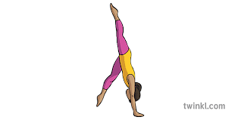

***“Hard days are the best because that’s when champions are made.”***

**– Mav Levy**

|  |  |  |
| --- | --- | --- |
| **Lyng Primary School P.E Knowledge Organiser** | | |
| **Topic: GYMNASTICS** | Year 6 | Spring 1 |

Learning Outcomes

* To be to perform a variety of stands and positions.
* To create group point balances.
* To be able to hold a handstand.
* To be able to complete sequences with a good formation.
* To be able to perform jumps and leaps when using equipment in a sequence.
* To be able to mount, dismount & perform jumps when using a bench.

